Algebra 2 Concept Practice – Chapter 6
Simplify the rational expressions below by performing the operations.
1. 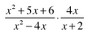 2. 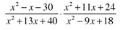

3. 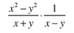 4. 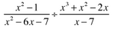

5. 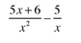 6. 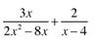

7. 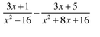 8. 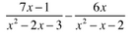

Answers:
1. 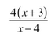 2. 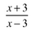 3. 4. 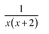
5. 6. 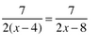 7. 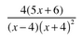 8. 