Algebra 2 Concept Practice – Chapter 6

Create a table from  for the equations then graph it’s inverse. Only plot those values which fit on the graph. These should all be completed without a calculator.

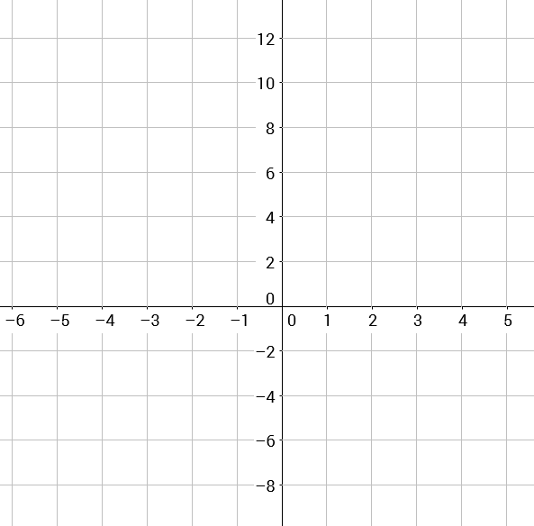1. 

Original Table

Inverse Table

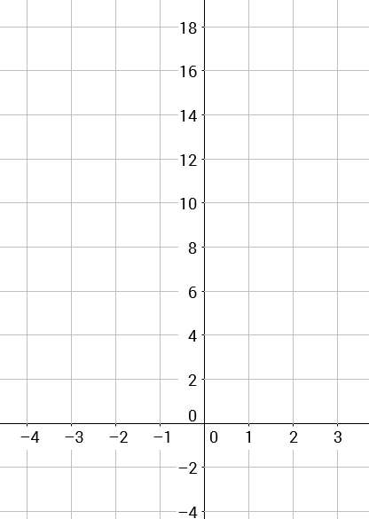

2. 

Original Table

Inverse Table

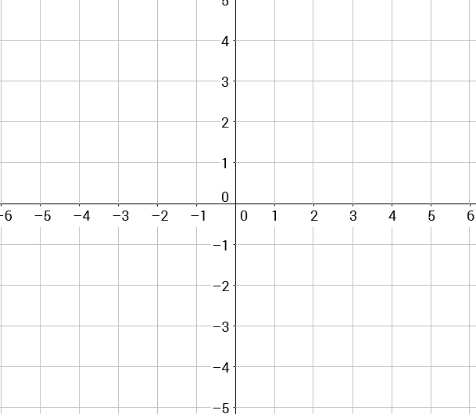3. 

Original Table

Inverse Table

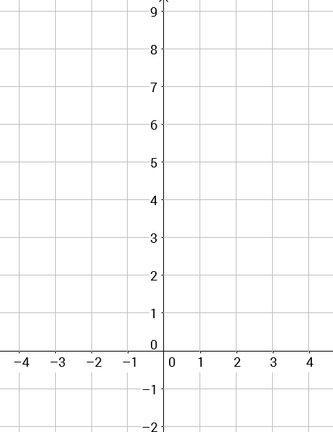

4. 

Original Table

Inverse Table